**MAGIS & RYAN REFILLING AND LAUNDRY STATION**

2013

**USER MANUAL**

**REFILLING AND LAUNDRY APPLICATION**

**BY: MARVIN, JULIE ANN AND VANESSA**

Table of Contents

MAIN FORM 3

COMPANY INFORMATION 3

CUSTOMER LIST 4

REFILLING 6

NEW 6

SEARCH/DELETE 7

RETURN/PAYMENT 8

REPORTS 10

CONFIGURATION 11

LAUNDRY 11

NEW 11

CLAIM 16

REPORTS 16

CONFIGURATION 17

# MAIN FORM

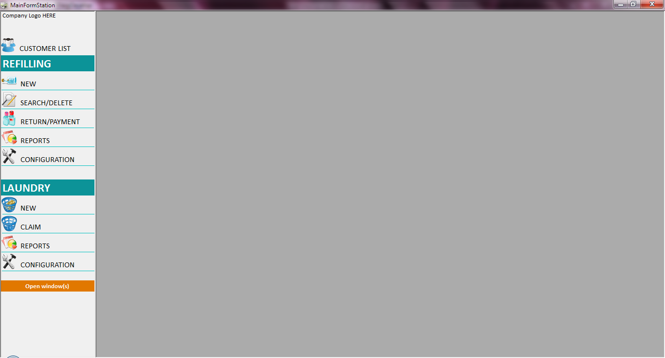

# COMPANY INFORMATION

Click on the Company Logo to view the Company Information and Printer Settings.

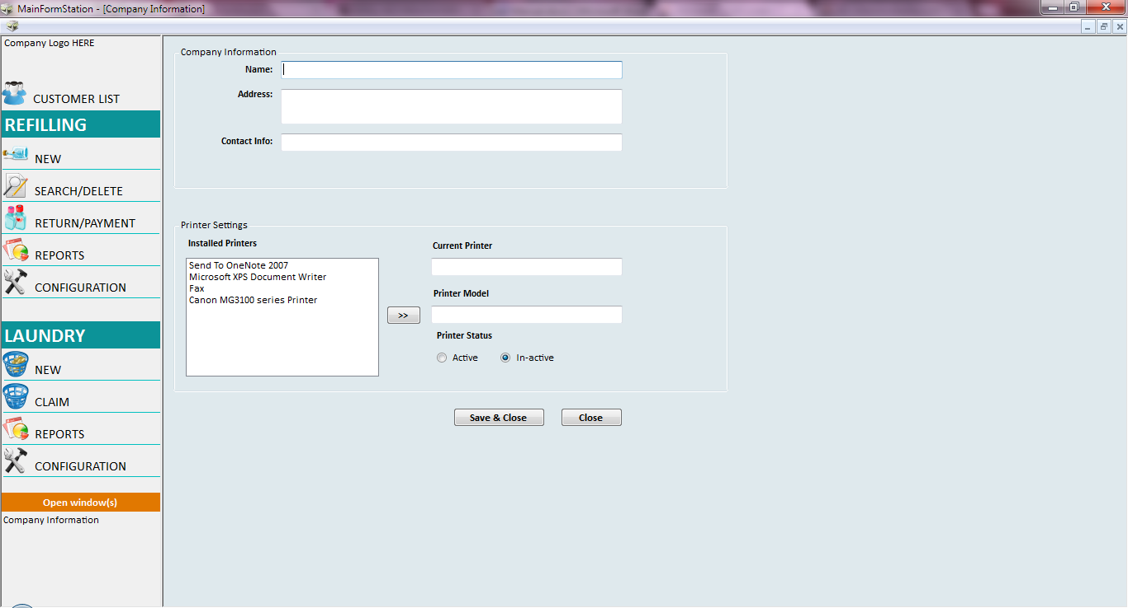

#### Company Information

* Company Information details will be displayed in the printed transaction slips.

#### Printer Settings

* Installed Printers
  + This contains the list of printers installed in the system.
  + User needs to select from the list of installed printers to be used in printing the transaction slips.
  + Click on  to show the details of the selected printer *(Printer Model, Printer Status)*

#### Window Buttons

* Save & Close
  + Save the changes made and closes the Company Information window.
* Close
  + Closes the Company Information window.

# CUSTOMER LIST

Use this window to add new customer and update existing customer information. The customers from Laundry and Refilling shops will be viewed in this window. For new customer, user has to add the customer before creating a transaction.

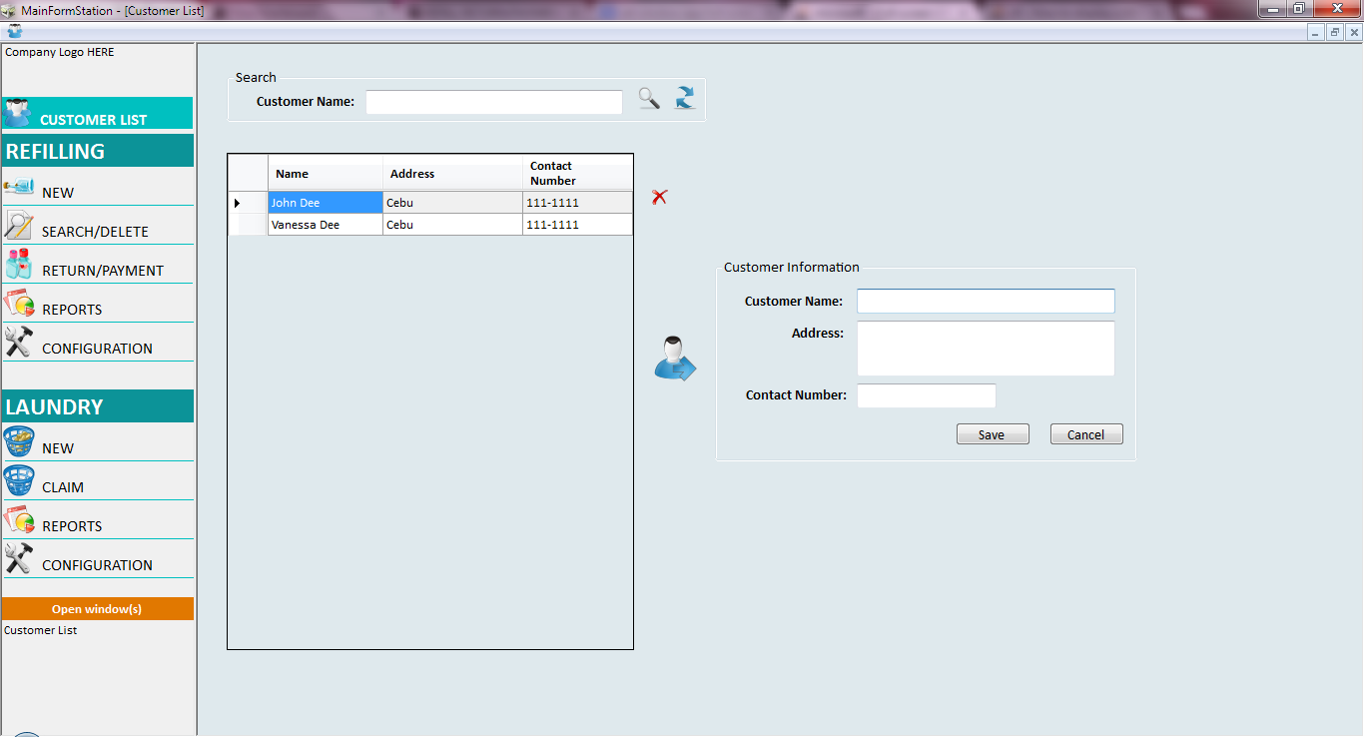

#### Search Customer

* Customer Name textbox 
  + Type in the customer name you want to search from the list.
* Search button 
  + Search for the customer name entered in the Customer Name textbox. A customer list containing the searched name will be displayed in the grid view.
  + If no certain customer exists, a message prompt will be displayed.
* Refresh button 
  + It will load the complete list of customers.

#### Customer List Grid View

* + It will display all customers added in the application. This contains the customer information.
* Add New Customer
  + Use the Customer Information to add a new customer. Customer Name must not be empty or duplicate with existing customer to successfully save the new customer.
  + Use Cancel button to clear the data in Customer Information.
* Edit Customer Detail
  + Select a certain customer to view or update its information. Click on the first column  to select the entire row of a certain customer. User can only select one customer at a time to view its information.
  + Click on Customer icon  to view the customer’s data in Customer Information. Click on Save button to update the changes made in the Customer Information.
* Delete Customer
  + Select a customer you want to delete from the list. Use the first column  to select the entire row of a certain user. User can also select multiple customer record to delete from the list.
  + Click on Delete button  to remove the selected customer from the list. If the selected customer has a pending transaction, a message prompt will be displayed notifying the user that the customer has a pending transaction and will not be removed from the customer list.

# REFILLING

## NEW

Use this window to create a new transaction for Refilling.

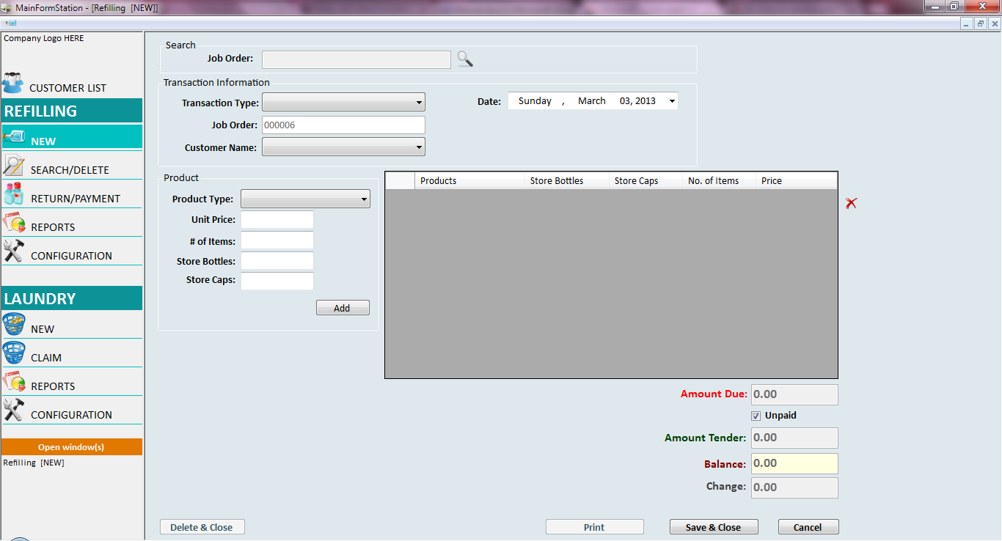

#### Transaction Information

* Transaction Types
  + Delivery
  + Walk-in
* Job Order
  + Job order number is pre-populated by the application. User needs the job order number to retrieve the transaction.
* Customer Name
  + User can select a customer name from the dropdown list. If customer doesn’t exist in the application, user has to add the new customer in the *Customer List*.
* Date
  + Date that the transaction is made.

#### Product

* Product Type
  + A dropdown list of the product types being sold. A product type must be configured first in *Refilling Configuration – Product Type* to be reflected in this dropdown list.
* Unit Price
  + Unit price of the product type selected.
* # of Items
  + Number of items to be purchased for a certain product type.
* Store Bottles
  + This will only be enabled when a 5 Gal product type is selected.
  + Input number of store bottles being released to the customer.
  + The Inventory for store bottles will be updated every time the store released a new bottle to the customer. See *Inventory* for details.
* Store Caps
  + This will only be enabled when a 5 Gal product type is selected.
  + Input number of store caps being released to the customer.
  + The Inventory for store caps will be updated every time the store releases a new store caps to the customer. See *Inventory* for details.
* Add button
  + Click the Add button when an order of a specific product type is finalized. The order will be reflected in the summary list view.

#### Order Details

* All orders added will be viewed in the data grid. In cases where user made a mistake in adding an order, user can remove the said order by clicking the entire row of the detail order and click on the delete button  located beside the data grid.

#### Payment Details

* Amount Due
  + Amount Due will be updated every time a user adds an order.
* Unpaid checkbox
  + Some customer has an option to pay the amount due on a later date. User has to check the Unpaid checkbox to disable the Amount tender textbox.
* Amount Tender
  + User enters the amount tendered by the Customer.
* Balance
  + It will compute the remaining balance of the customer if the payment made is lesser than the amount due.
* Change
  + It will compute the change if the payment made is greater than the amount due.

#### NEW Window Buttons

* Save & Close
  + When user finalizes the order of the customer, click the Save & Close button to save the transaction. Note that once a transaction is saved, the user can’t modify the details of the transaction. If the customer wants to add a new item, the user needs to create a new transaction for the additional item. In cases where the user inputs the wrong order and saved the transaction, user has to go to *SEARCH/DELETE* window and void the said transaction.
  + When a transaction is successfully saved, the user will be prompted an option to print an order slip when a customer demands for it.
* Cancel
  + This will clear the inputted data.

## SEARCH/DELETE

Use this window to view the details of a certain transaction and voiding a transaction.

## 

#### Search Job Order

* Job Order textbox
  + User inputs the Job order number to view the transaction details.
* Search button
  + Click on search button to view the transaction details.

#### SEARCH/DELETE Window Buttons

* Delete & Close
  + User has an option to void a certain transaction. Payments made will be reverted when a transaction is being voided.
* Print
  + User has an option to print an order slip when a customer asks for it.

## RETURN/PAYMENT

Use this window to track the returned bottles and caps of a specific customer and this will also display all unsettled transactions of the said customer. User will also use this window when a customer pays for the outstanding balance.

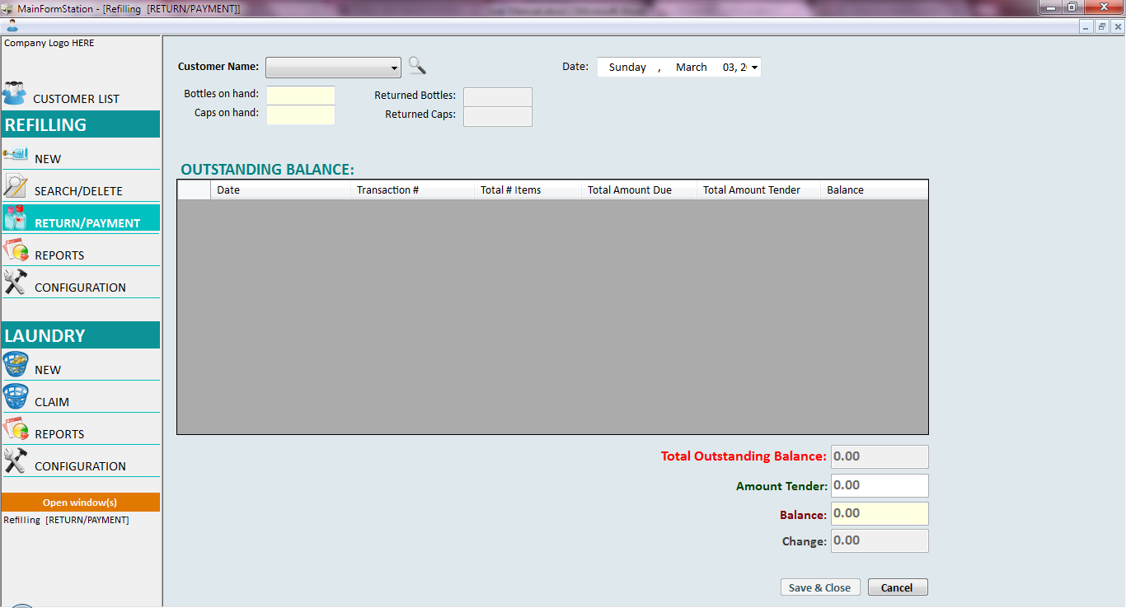

#### Search Customer

* Select from the Customer Name dropdown list and click on the search button  to view the customer’s data.

#### Inventory Items

* Bottles on Hand and Caps on Hand
  + This will show the number of bottles and caps released to the customer.
* Returned Bottles and Returned Caps
  + If customer has no bottles or caps on hand, the textbox for returned items will be disabled.
  + Every time the customer returned an item, user will input the number of returned items to update the remaining items on hand and as well as to update the Refill Inventory. See *Inventory* for details.

#### Outstanding Balance

* This will show all unsettled transactions made by a certain customer.

#### Payment Details

* Total Outstanding Balance
  + Total amount that a customer needs to settle.
* Amount Tender
  + User enters the amount tendered by the Customer.
* Balance
  + It will compute the remaining balance of the customer if the payment made is lesser than the amount due.
* Change
  + It will compute the change if the payment made is greater than the total outstanding balance.

#### RETURN/PAYMENT Window buttons

* Save & Close
  + Saved all changes made and closes the RETURN/PAYMENT window
* Cancel
  + Clears the inputted value in Returned Items and Amount tender.

## REPORTS

Use this window to generate a report for Refilling.

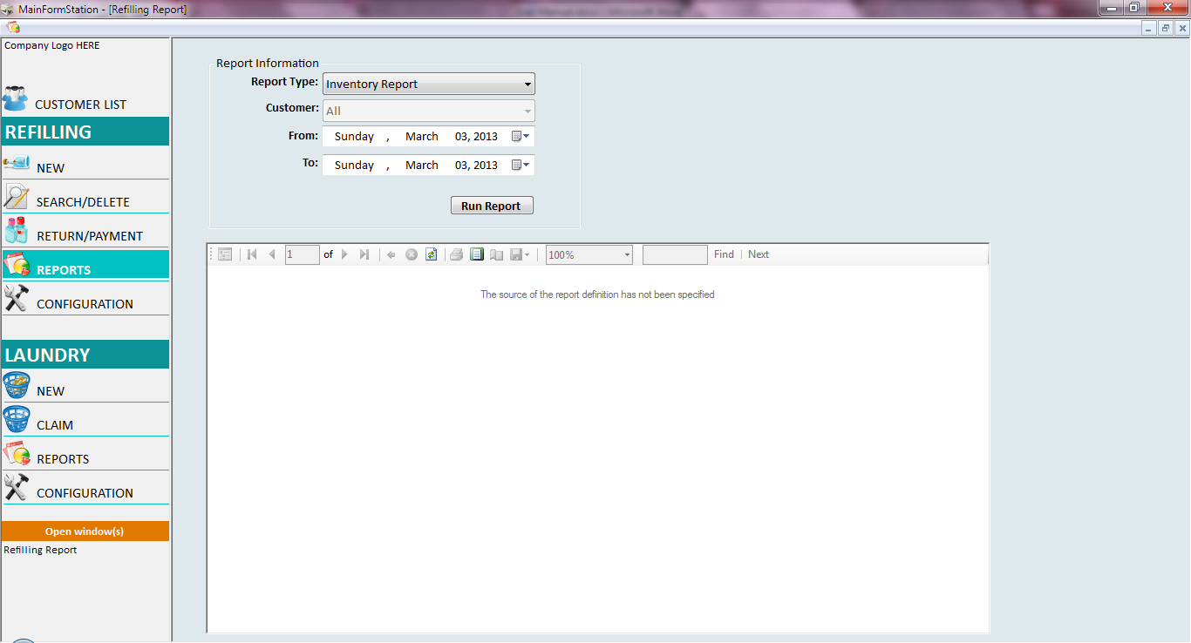

#### Report Types

* Inventory Report
  + Summary report for the items restocks, on-hand, damage and released to the customer.
* Inventory Activity Report
  + Detailed tracking report for the items restocks, on-hand, damage and released to the customer.
* Customer Inventory Report
  + Report for the items released or returned by the customer for a specific duration.
* Sales Report
  + Report for all payments made for a specific duration.
* Unpaid Transactions Report
  + Reports for all unsettled transaction made by the customer for a specific duration.
* Void Transactions Report
  + Reports for all voided transaction made by the user for a specific duration.

#### Customer

* Default value is for ALL customers but user has an option to generate a report for a specific customer.

#### Report Duration

* Date period of the data to be shown in the report.

## CONFIGURATION

Use this window to configure the price scheme of the Refill product.

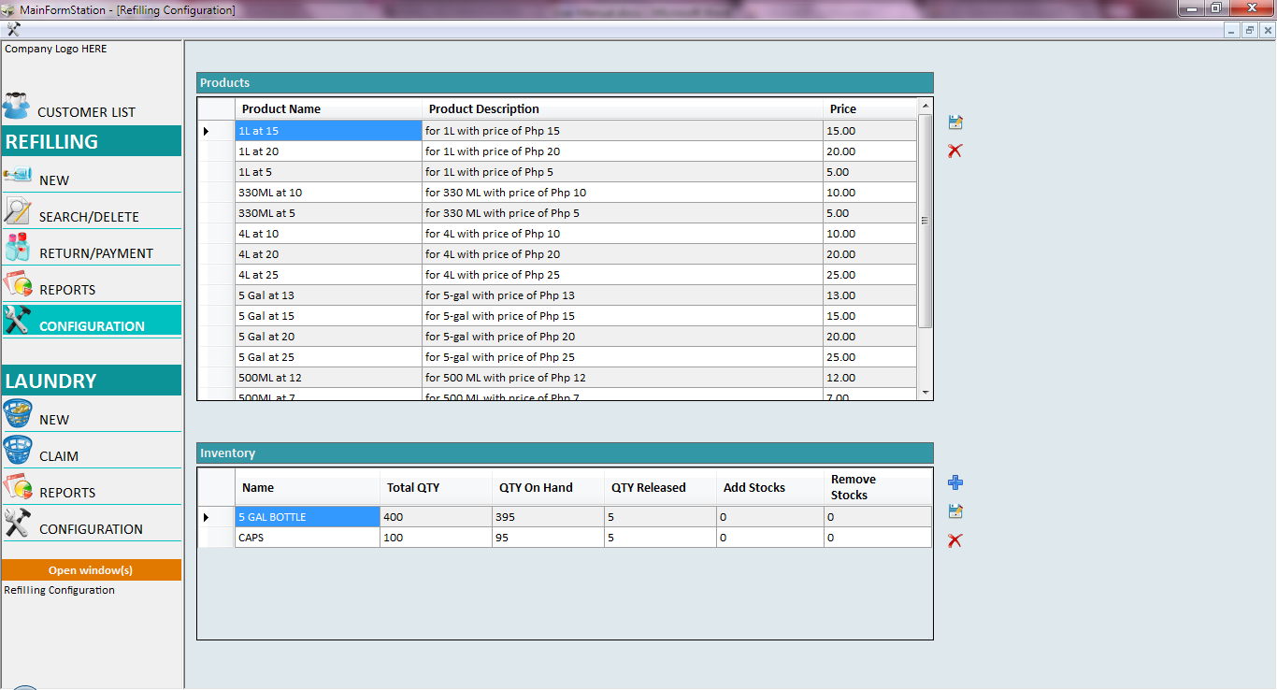

#### Product Type

* User will configure the pricing scheme of the Refill products. The configured price scheme will be reflected in the Product section in creating NEW transaction. See NEW window for details.
* User can directly modify the product name, description and price. Click on Save button  to save modified product type information.
* User can add new product type at the end of the list. An empty row is provided to the user to add a new product type. Click on Save button  to save the new product type.
* To delete a product type, user has to select the entire row of the product type to be deleted. Click on the Delete button  to remove the selected product type.

#### Inventory

* Only 5 GAL BOTTLE and CAPS are being tracked in the application from released to return of items but user can still add a new item to track the restocks and damaged stocks.
* For existing items, user can only add stocks and removed stocks. User can’t modify the Item name once saved.
* For new item in the inventory, Click on Add button  to add new row in the grid view. Only name and add stocks text box is enabled for user to input a value.
* To delete an item in the inventory, user has to select the entire row of the item inventory to be deleted. Click on the Delete button  to remove the selected item.

# LAUNDRY

## NEW

Use this window to create a new transaction for LAUNDRY.

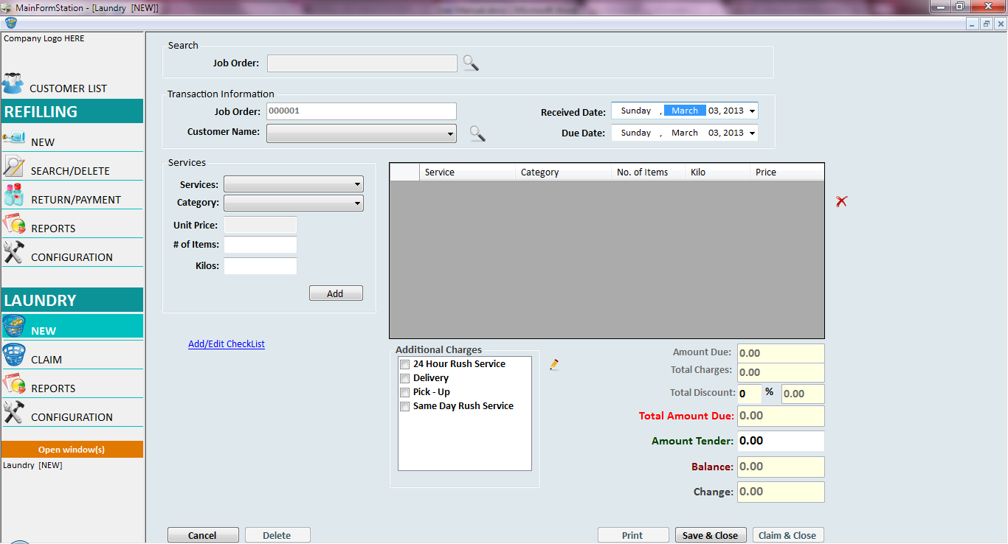

#### Transaction Information

* Job Order
  + Job order number is pre-populated by the application.
* Customer Name
  + User can select a customer name from the dropdown list. If customer doesn’t exist in the application, user has to add the new customer in the *Customer List*.
* Received Date
  + Date that the transaction is made.
* Due Date
  + Date that the customer can claim the items.

#### View Customer Unclaimed Transaction and Outstanding Balance

* User can view the unclaimed transaction or outstanding balance of a specific customer before creating a new transaction.
* User selects a customer name from the dropdown list and click on the Search button  to load the pop-up window to view Customer’s unclaimed transaction and outstanding balance.

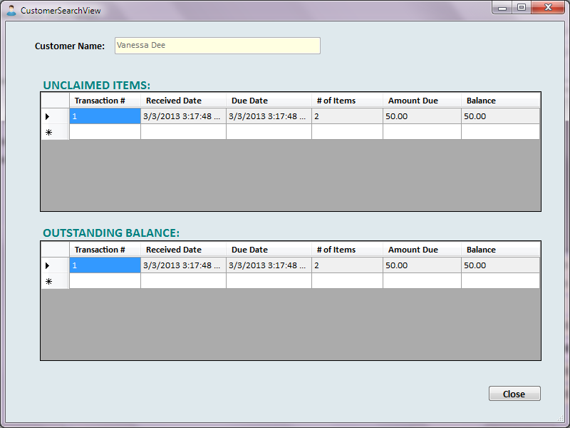

* Click on Close button to close the pop-up window and go back to NEW window and create new transaction.

#### Services Offered

* Services
  + A dropdown list of the services being offered. A service type must be configured first in *Laundry Configuration – Price Scheme* to be reflected in the dropdown list.
* Category
  + Dropdown lists of the category belong to the selected Service type. A category type must be configured first in *Laundry Configuration – Price Scheme* to be reflected in the dropdown list.
* Unit Price
  + Unit price of the service – category selected.
* # of Items
  + # of items
* Kilos
  + Total # of kilos of the service – category selected.

Click on Add button to reflect the specific order in the grid view. In cases where the user made a mistake on the order detail, user needs to select the order detail and click on the Delete button  to remove it on the order list.

#### Add/Edit Checklist

* User can update the checklist of a transaction in NEW or CLAIM window.
* Checklist is made to keep a record on the number of items of a specific category received by the user.

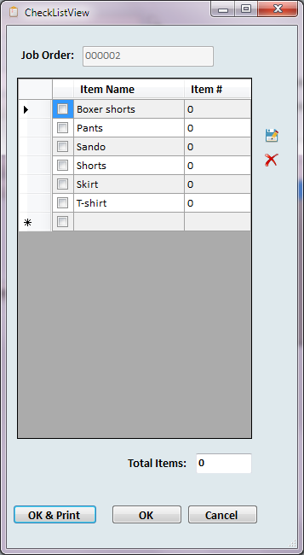

* User can update the item list.
  + User can modify the item name. Click on Save button  to save the changes made.
  + User can add new item name, user needs to input the item Name on the last row and click on Save button  to save the newly added item.
  + User can delete an existing item, user needs to select the item to be removed and click on the Delete button  to remove the selected item from the list.
* User then inputs the number of items of a particular category received.

###### Checklist buttons

* OK & Print
  + Save the changes made and prints a checklist slip to be given by the customer.
* OK
  + Save the changes made.
* Cancel
  + Close the checklist window and go back to NEW window screen.

#### Additional Charges

* Special services are also offered like 24 hour rush service, delivery and etc.
* User checks the special services that the customer avails, the amount of the availed service will be reflected in the Total Charges in Payment Details.
* User can modify the additional charges list by clicking on the Edit button  to load the Additional Charges pop-up window.

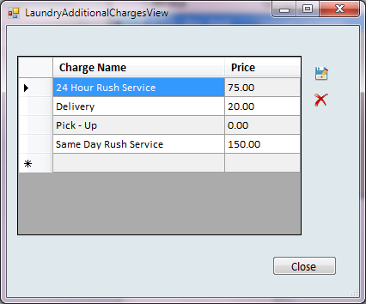

* User can update the charge list.
  + User can modify the charge name and price. Click on Save button  to save the changes made.
  + User can add new item name, user needs to input the charge Name and Price on the last row and click on Save button  to save the newly added charge.
  + User can delete an existing item, user needs to select the item to be removed and click on the Delete button  to remove the selected item from the list.

###### Additional Charges Window button

* Close
  + Closes the additional charges window and go back to NEW window screen.

#### Payment Details

* Amount Due
  + Total amount of the order details added.
* Total Charges
  + Total charges amount based on the selected special service availed by the customer.
* Total Discount
  + User has an option to give a discount. User inputs the percent discount given to the customer on the first text box. The discount amount will be reflected on the second text box.
* Total Amount Due
  + Total amount due = Amount Due + Total Charges - Discount
* Amount Tender
  + User inputs the amount tendered by the customer.
* Balance
  + It will compute the remaining balance of the customer if the payment made is lesser than the amount due.
* Change
  + It will compute the change if the payment made is greater than the total outstanding balance.

#### NEW Window buttons

* Cancel
  + Clears the inputted data.
* Save & Close
  + Save the transaction and closes the window.

## CLAIM

Use this window to view, pay, claim and avoid a transaction. Note that in CLAIM window, user can’t add a new order detail to the existing transaction. Only additional charges can be added to the transaction.

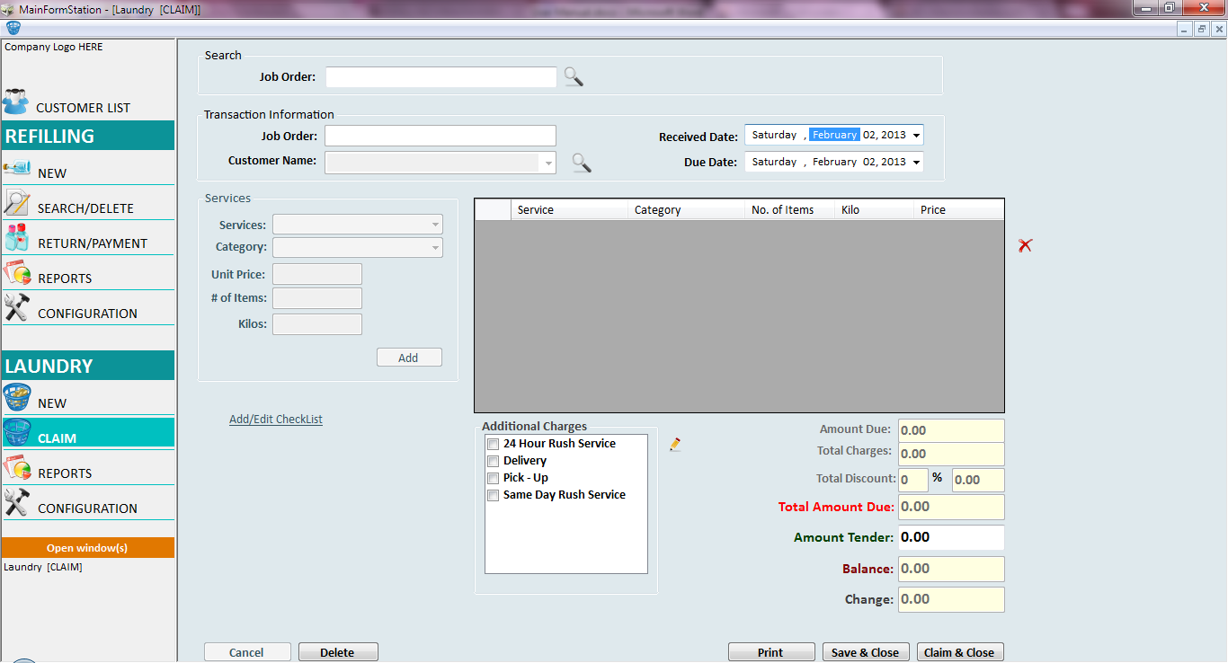

#### Search

* Input the job order number to view the details of a transaction

#### Additional Charges

* User can add charges to the unclaimed transaction

#### Payment Details

* Amount Tender
  + User inputs an amount tendered by the customer. Customer has an option to do a partial payment of the transaction before claim.

#### CLAIM Window Buttons

* Delete
  + User has an option to void a certain transaction. Payments made will be reverted when a transaction is being voided.
* Print
  + This will print a job order slip and claim slip for customer’s reference.
* Save & Close
  + Saves the changes made in a transaction and closes the window.
* Claim & Close
  + User flag a transaction that is being claimed by the customer and closes the window.
  + Note that a transaction cannot be claimed if there is an outstanding balance.

## REPORTS

Use this window to generate reports for Laundry.

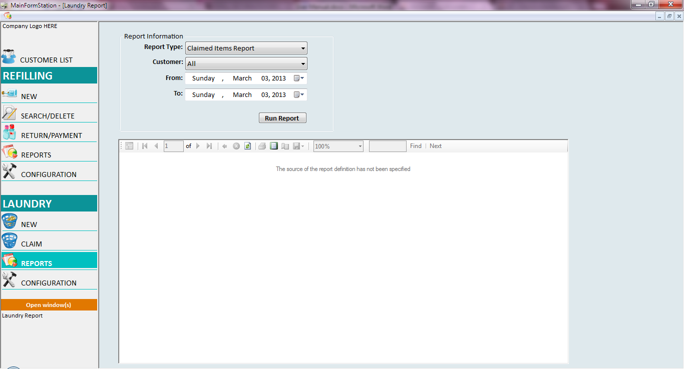

#### Report Types

* Claimed Items Report
  + Report for all Claimed transaction.
* Sales Report
  + Report for all payments made for a specific duration.
* Unclaimed Items Report
  + Report for all Unclaimed transaction.
* Unpaid Transaction Report
  + Report for all unsettled transaction made by the customer for a specific duration.
* Void Transaction Report
  + Report for all voided transaction made by the user for a specific duration.

#### Customer

* Default value is for ALL customers but user has an option to generate a report for a specific customer.

#### Report Duration

* Date period of the data to be shown in the report.

## CONFIGURATION

User this window to configure the Price Scheme of the services being offered.

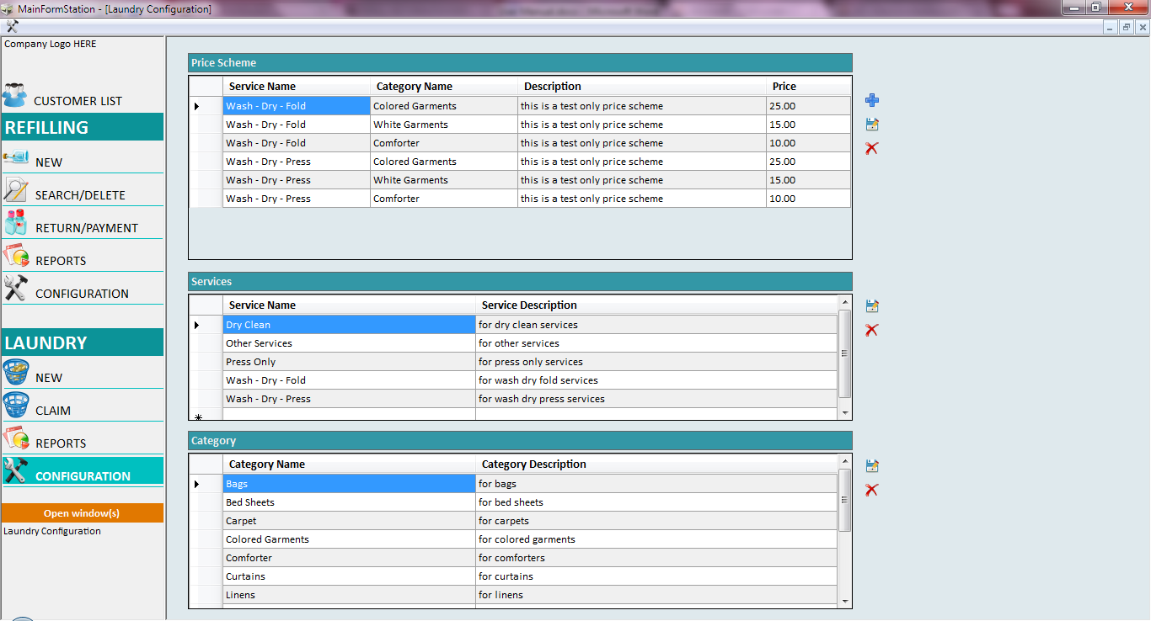

#### Price Scheme

* User will configure the pricing scheme of the services offered. The configured price scheme will be reflected in the Service section in creating a NEW transaction. See NEW window for details.
* User can only modify the description and price of the existing price scheme entry. Click on Save button  to save the changes made.
* For new price scheme, Click on the Add button  to add a new row in the grid view. User now selects the service and category dropdown list, inputs the description and price of the new price scheme. Click on Save button  to save the new price scheme. A message will be prompted when user saves a duplicate entry.
* To delete a price scheme, user has to select the entire row of the price scheme to be deleted. Click on the Delete button  to remove the selected price scheme from the list.

#### Services

* User will configure the services being offered. The service list will be reflected in the Price Scheme table.
* User can modify the service name and description. Click on Save button  to save modified service information. Modifications made in the service name will be reflected in the Price Scheme table.
* User can add new service at the end of the list. An empty row is provided to the user to add a new service type. Click on Save button  to save the new service type. A message will be prompted when user saves a duplicate entry.
* To delete a service type, user has to select the entire row of the service type to be deleted. Click on the Delete button  to remove the selected service type.

#### Category

* User will configure the category list. The category list will be reflected in the Price Scheme table.
* User can modify the category name and description. Click on Save button  to save modified category information. Modifications made in the category name will be reflected in the Price Scheme table.
* User can add new category at the end of the list. An empty row is provided to the user to add a new category type. Click on Save button  to save the new category type. A message will be prompted when user saves a duplicate entry.
* To delete a category type, user has to select the entire row of the category type to be deleted. Click on the Delete button  to remove the category type.